**Assignment No- 4**

1)..Build a class Student which contains details about the Student and compile and run its instance.

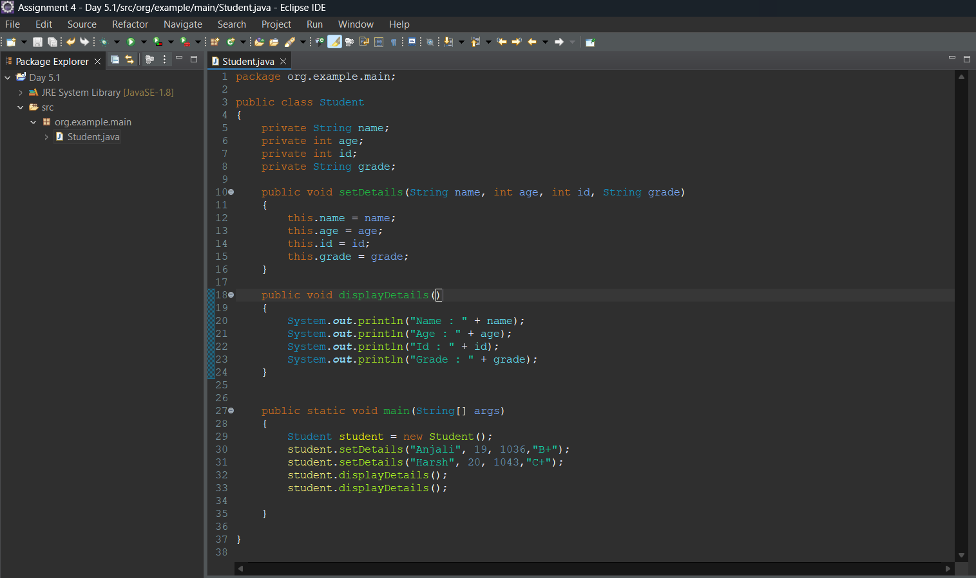

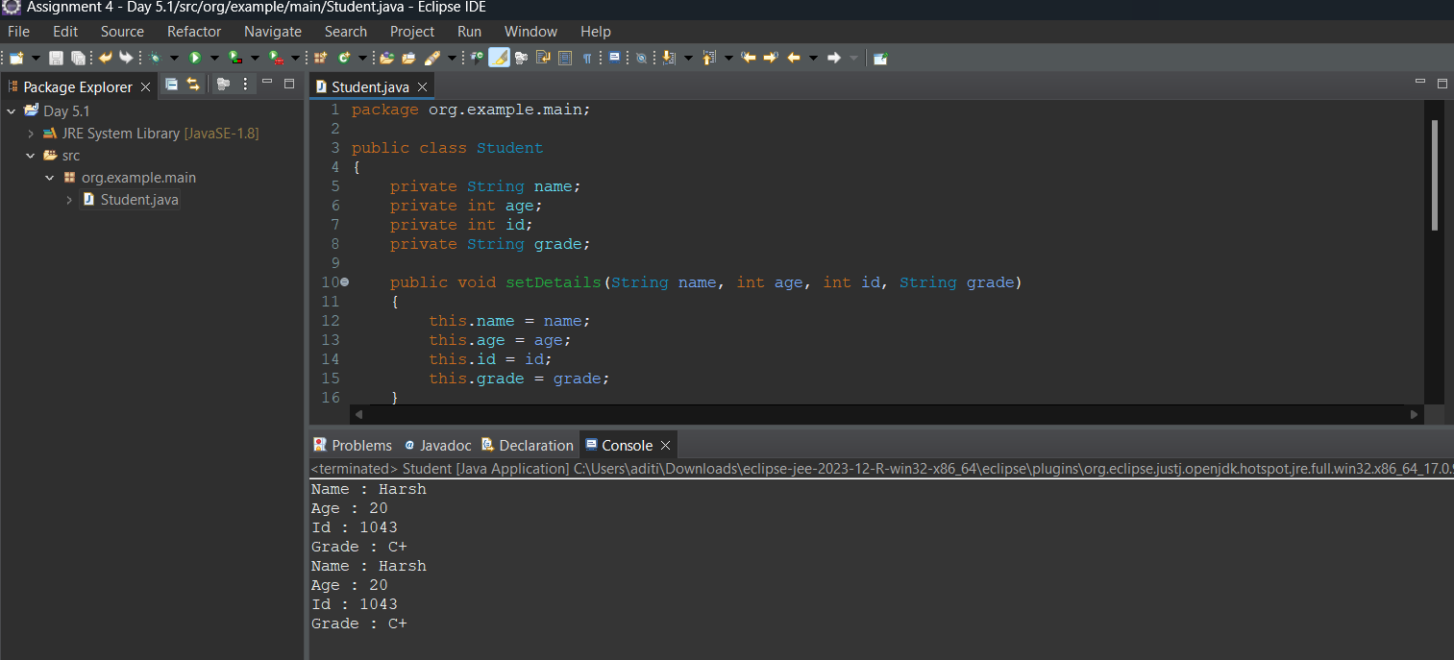

2)..Write a Vehicle class with overloaded methods that have a different number of parameters. Demonstrate calling these overloaded methods with various numbers of arguments.

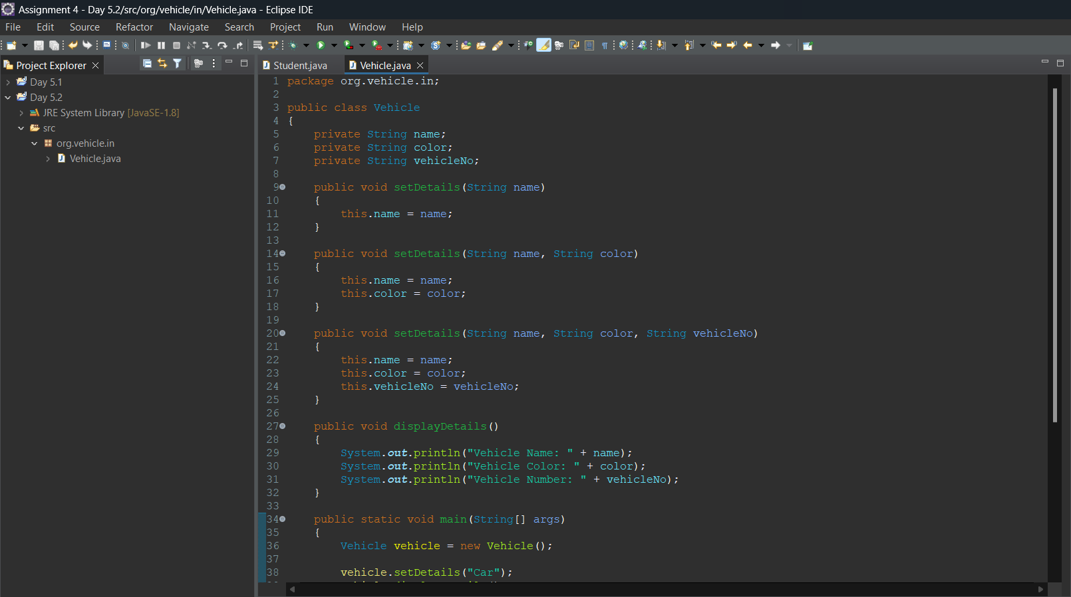

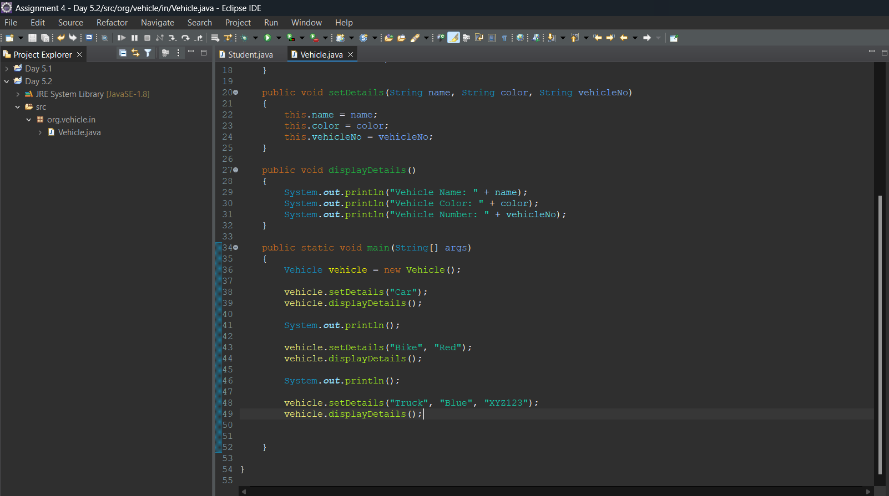

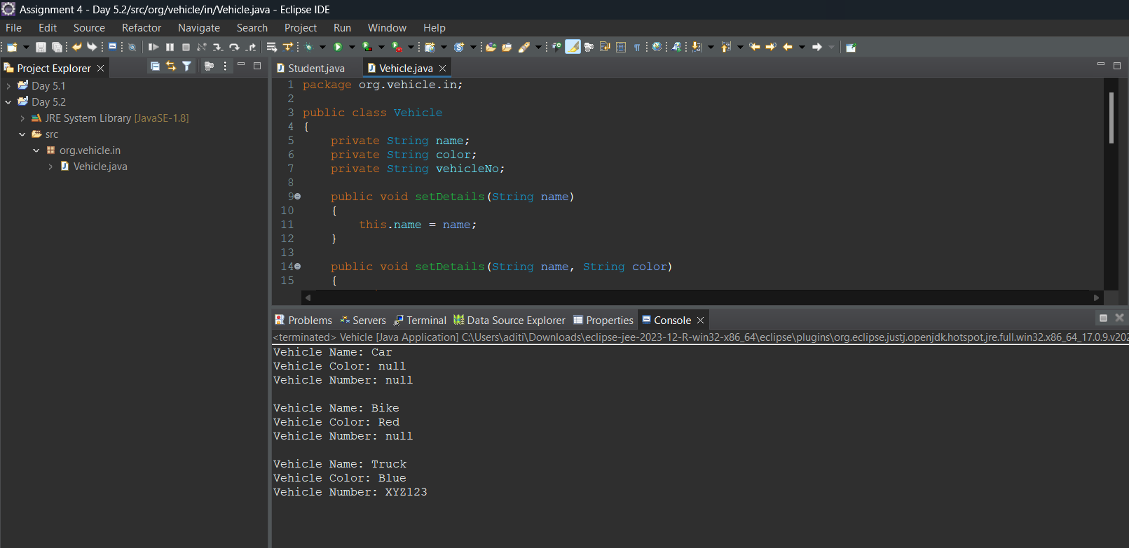

3)..Create a class Employee with multiple overloaded methods that have different parameter types (e.g.,int, double, String). Demonstrate calling each overloaded method with appropriate arguments.

